Calvert Green Parish Council – New Play Area Proposal

Due to the continued deterioration of the outdoor play spaces and the success of the new play space at Rustics Close, Buckinghamshire Council are now planning to close several of the play locations on offer to our children and build a brand new open space adjacent to the village hall.
This new play area would cater for a wide variety of age groups and be sited near to the village hall with views over the green. The trees between the new play area and the road would be ‘crown lifted’ i.e. the lower branches would be removed, giving greater visibility through to the equipment from the footpath.
Play areas numbered 1, 2 and 3 would be removed and replaced with appropriate landscaping. The Parish Council have asked whether one area (2) could be made into a picnic spot with tables and seating. The basketball / sports court would remain unchanged.
In light of this, we would like to ensure that we consult with as many families as possible who use, or will use, these areas to ensure that the design of the play area and the equipment installed within, best meets our needs
Therefore, if you have any comments or suggestions for the sort of equipment or the type of materials that you would like to see in these areas please email the parish council:
clerk@calvertgreenparish.co.uk
You could also let us know what sort of experience you would like your children to get out of their visits to the play areas e.g. challenging, developmental, learning etc.
In the meantime if you could please complete the questionnaire overleaf and return it to us by Saturday 31st October, we would be most grateful for your input. Completed questionnaires can be:
- placed in the designated box in the village hall,
- scanned and emailed to the address above, or
- put through one of these letterboxes:
1 Heathers Close, 4 Fletton End, 11 Rustics Close, 70 Cotswolds Way, 52 Cotswolds Way or 35 Cotswolds Way
Even if your children or grandchildren have grown-up and would not use these play areas any more, perhaps you could ask them what equipment they would have liked or what materials they might have preferred.
All information supplied will be treated in the strictest confidence.
Many thanks

Calvert Green currently has 5 play areas. How frequently do you or members of your family use these areas (or would have used in the past)? Please tick any that apply.

 | Daily | 2 to 3 times a week | 2 to 3 times a month | Less than once a month | Never
Tudors Close (1) | ⚪ | ⚪ | ⚪ | ⚪ | ⚪
Cotswolds Way (2) | ⚪ | ⚪ | ⚪ | ⚪ | ⚪
Sandstone Close (3) | ⚪ | ⚪ | ⚪ | ⚪ | ⚪
Sports / basketball Court | ⚪ | ⚪ | ⚪ | ⚪ | ⚪
Rustics Close - new | ⚪ | ⚪ | ⚪ | ⚪ | ⚪

What age are your children or grandchildren?
Child | Age | Male | Female
1 | ⚪ | ⚪ | ⚪
2 | ⚪ | ⚪ | ⚪
3 | ⚪ | ⚪ | ⚪
4 | ⚪ | ⚪ | ⚪
5 | ⚪ | ⚪ | ⚪
6 | ⚪ | ⚪ | ⚪

Would any of these children have special needs that you would like taken into consideration? Please provide information below

Would a designated picnic spot with appropriate seating be of interest to you?
Yes ⚪ No ⚪

Please indicate below the type of equipment your children or grandchildren might enjoy
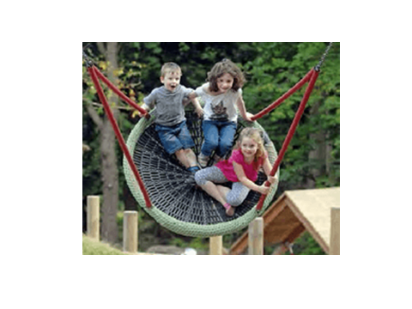
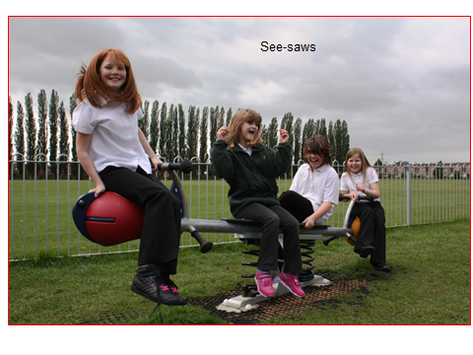
Seesaws and rocking ⚪ Group swinging ⚪ Gliding ⚪
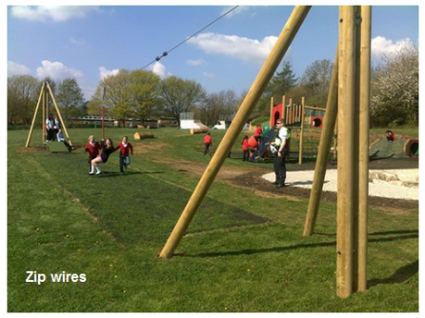

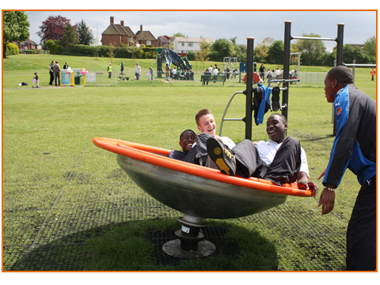
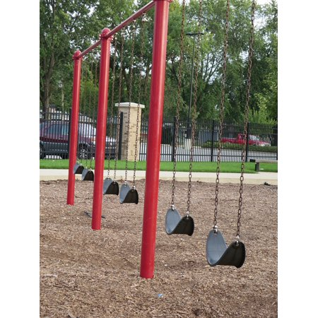
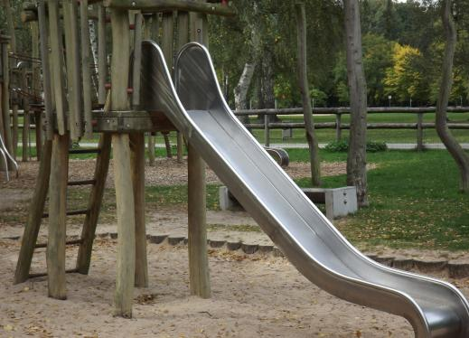
Spinning ⚪ Slides ⚪ Swings ⚪

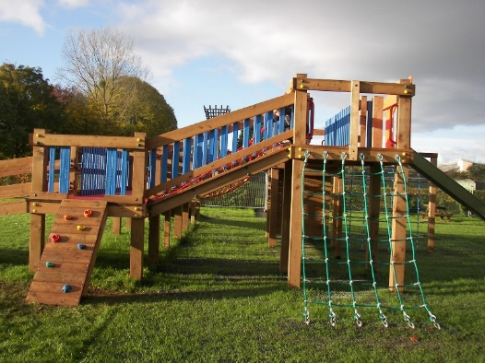
Towers and bridges ⚪ Balancing ⚪
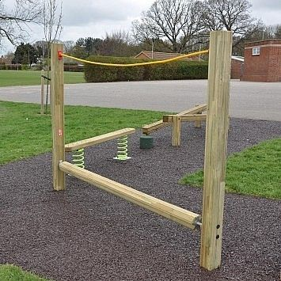
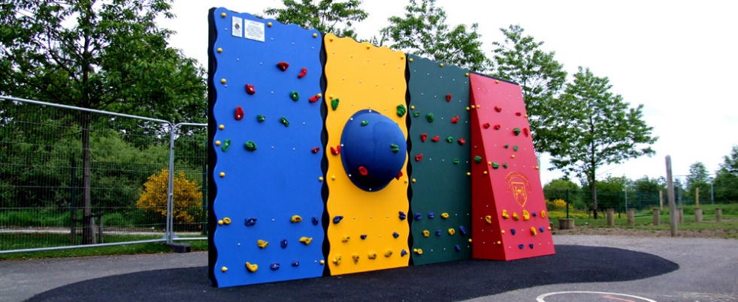

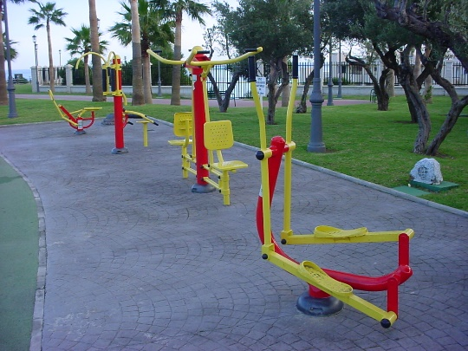
Climbing ⚪ Outdoor gym ⚪

What style would you, your children or grandchildren prefer?
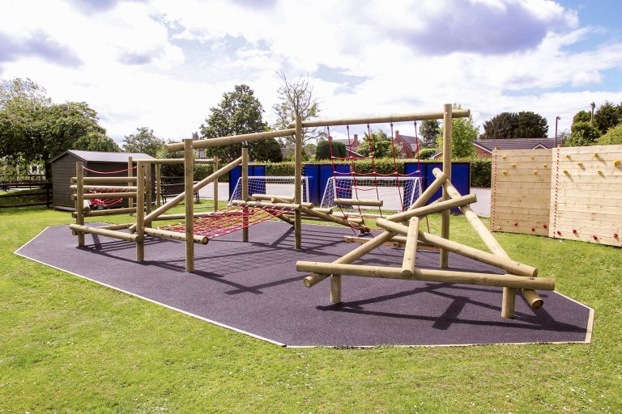
Mostly natural e.g. wood ⚪

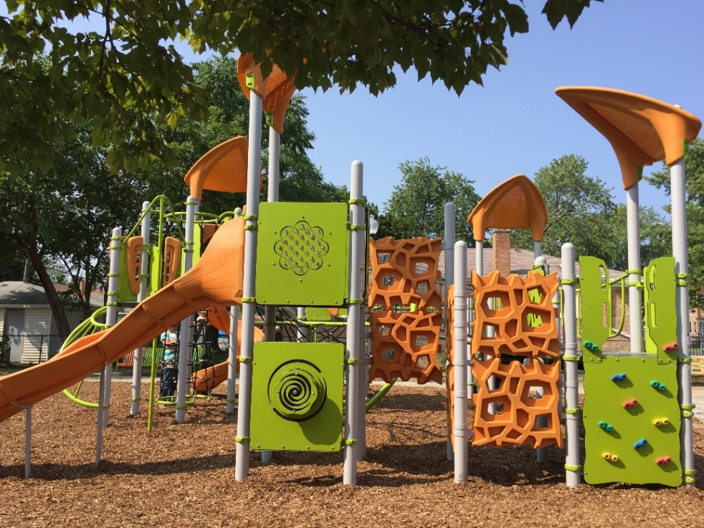
Modern e.g. metal ⚪

A mixture of both ⚪
If you would like to receive more information about the plans for the play areas, directly from the Parish Council, please complete the following:
Name: Mr. Mrs. Miss Ms
Email address:

Please add any further notes, comments or suggestions overleaf

Notes, comments and suggestions:

